Some questions I could put on an exam:

General problem set up | A specific example
1. Find and explain the function that goes along with a given pattern | Find and explain the function that tells how many yellow cubes are needed to make the nth pattern: (where these are 1 2 and 3)  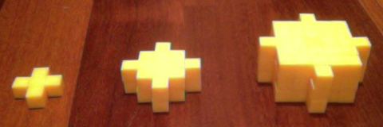  A complete answer should have not only the function rule, but also should have a geometric description that tells where each part of the function rule comes from.
2. Is the function that goes with a given pattern linear or non-linear? Explain how you know. It’s possible that I may ask this for a function that it would be very difficult to find the formula for | Is the function that tells the number of dots in each pattern linear or non linear?  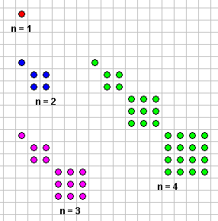
3. Show and explain how to fold patty paper into various shapes we have investigated, including: a square with half of the area (1 way) a triangle with ¼ of the area (3 ways), a perpendicular line, a parallel line, a square and an equilateral triangle. | Show and explain how to fold patty paper to make an equilateral triangle.
4. Show how to find the balance point of a triangle. | Find the balance point (center of gravity) of this triangle:

5. Explain how to find the interior angle of a regular polygon by starting with the central angle. | Show and explain how to find the interior angle of a regular 10-gon by starting with the central angle.
6. Sketch a 3D block shape onto isometric grid paper from several angles. | Build from blocks a 3D shape that has these front, top and side views. Draw your shape on isometric grid paper from 3 different angles.  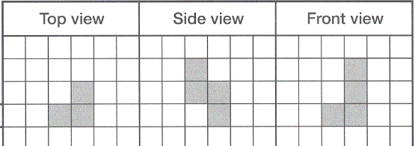  (linking cubes and isometric grid paper will be provided)
7. Describe an edge path from one point to another on a 3D block shape drawing. | Describe a path that will take you from point A to point B on this block shape. Use the notation U (straight up) D (down), U_{L} (diagonal up left), U_{R} (diagonal up right), D_{L} (diagonal down left), D_{R} (diagonal down right).  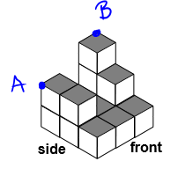
8. Explain what the Pythagorean theorem means. Show how to prove it for any right triangle on a grid | On a square grid draw a right triangle with legs of length 4 and 7. Draw squares on each side of the triangle. Show that the two smaller squares together have the same area as the larger square. You can show that the areas are the same by computing the area (in some way that doesn’t use the Pythagorean theorem, since that’s what we’re trying to prove), or you can show the areas are the same by decomposing and composing shapes.

9. Draw in all of the lines of symmetry you can find on a tessellation or wallpaper pattern. | Draw in all of the lines of symmetry. Assume that the pattern continues in all directions.  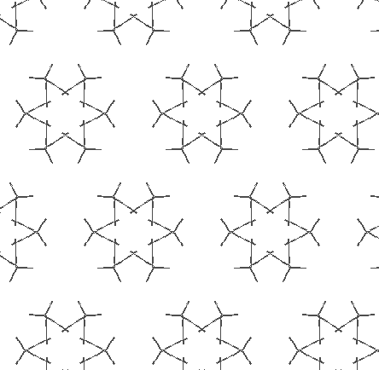
10. Draw in all of the center points and find rotational angles for rotational symmetry in a tessellation or wallpaper pattern. | Draw in all of the points of rotational symmetry. Indicate the rotation angle for each instance of rotational symmetry.
11. For a rectangle on a grid, show how Pick’s theorem gives you the area by showing how each peg/dot corresponds to part of the area of the rectangle. For full points, show it in a way that has a clear pattern that extends to work for other rectangles | Draw a 5x7 rectangle on a (given) rectangular grid. Show how to decompose the rectangle into whole and half unit areas and show/explain how those correspond to interior and boundary pegs as given in Pick’s theorem.
12. Use Pick’s theorem to find an area on a grid | Use Pick’s theorem to find the area enclosed by this shape:

