Following the usual pattern (as shown in the video), draw out tangram shapes on top of the square below. Cut out the tangrams you just drew, so that you have a set of tangrams that matches the grid size for these problems.

These are the student instructions that go with this activity.
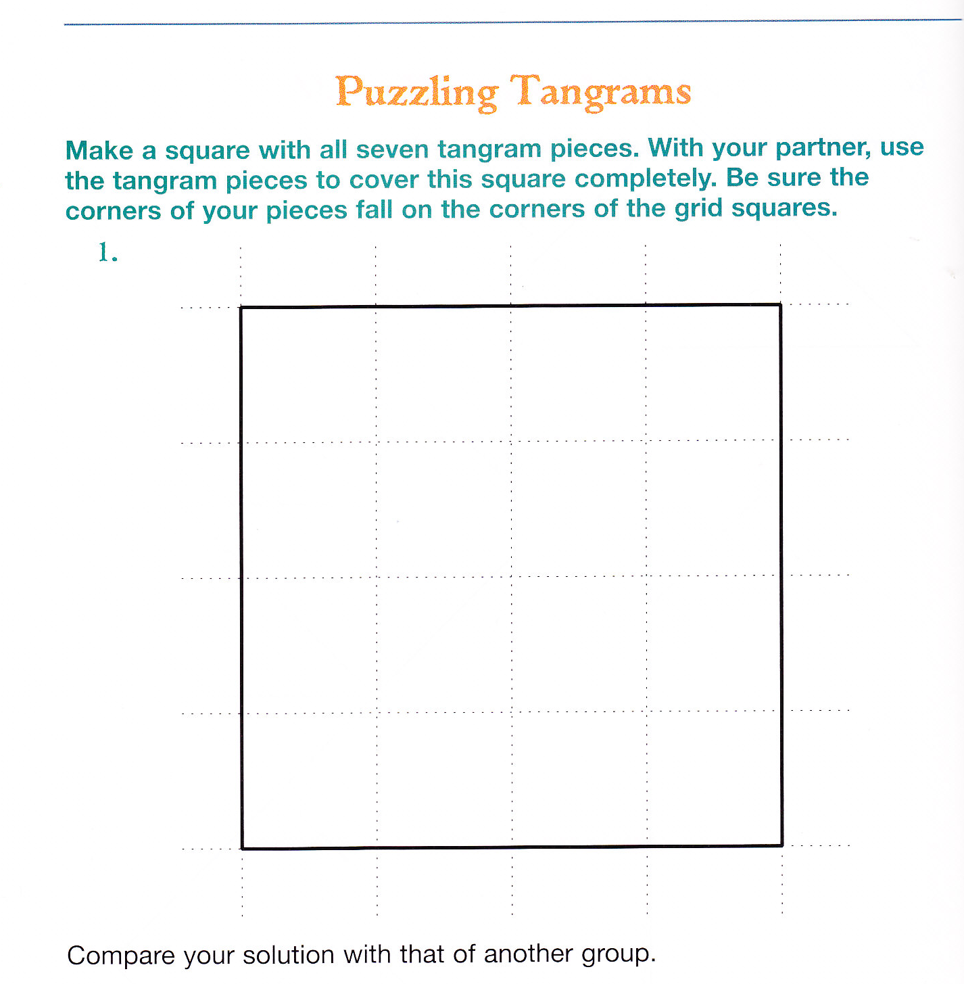

Here are the student instructions for this activity:

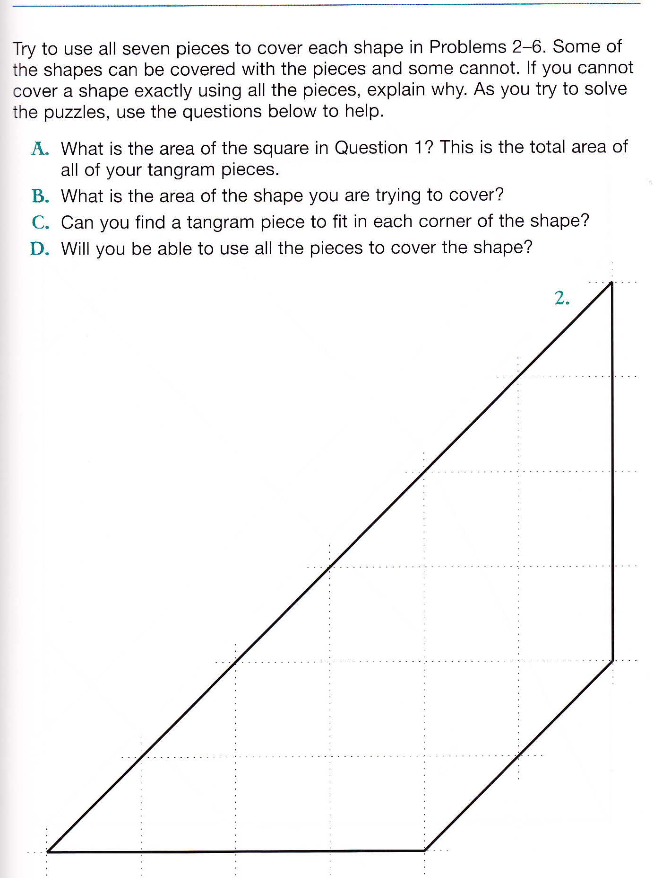
A. For each of these shapes, you should be telling the area in square units
B. For each of these shapes, you should try to cover it with tangrams. If you find an arrangement that makes the tangrams fit, trace your tangram shapes onto this shape to show your arrangement (some arrangements will use fewer than 7 tangrams).
C. If you find a shape that can’t be covered with any combination of the tangrams you have, explain how you know that it can’t be covered.
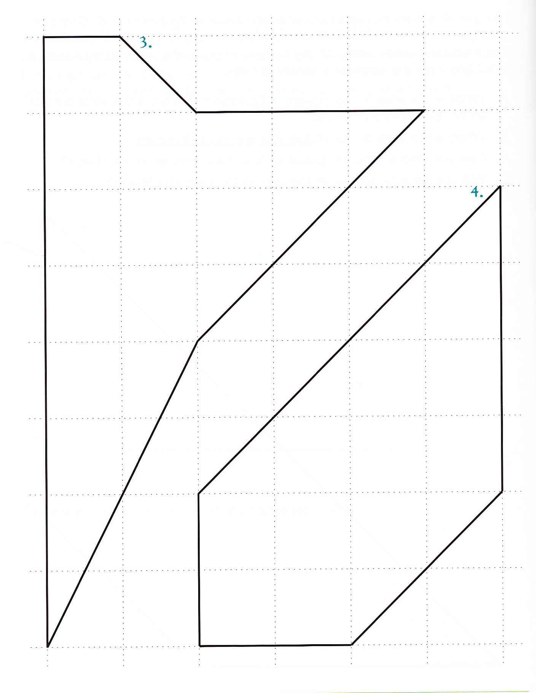

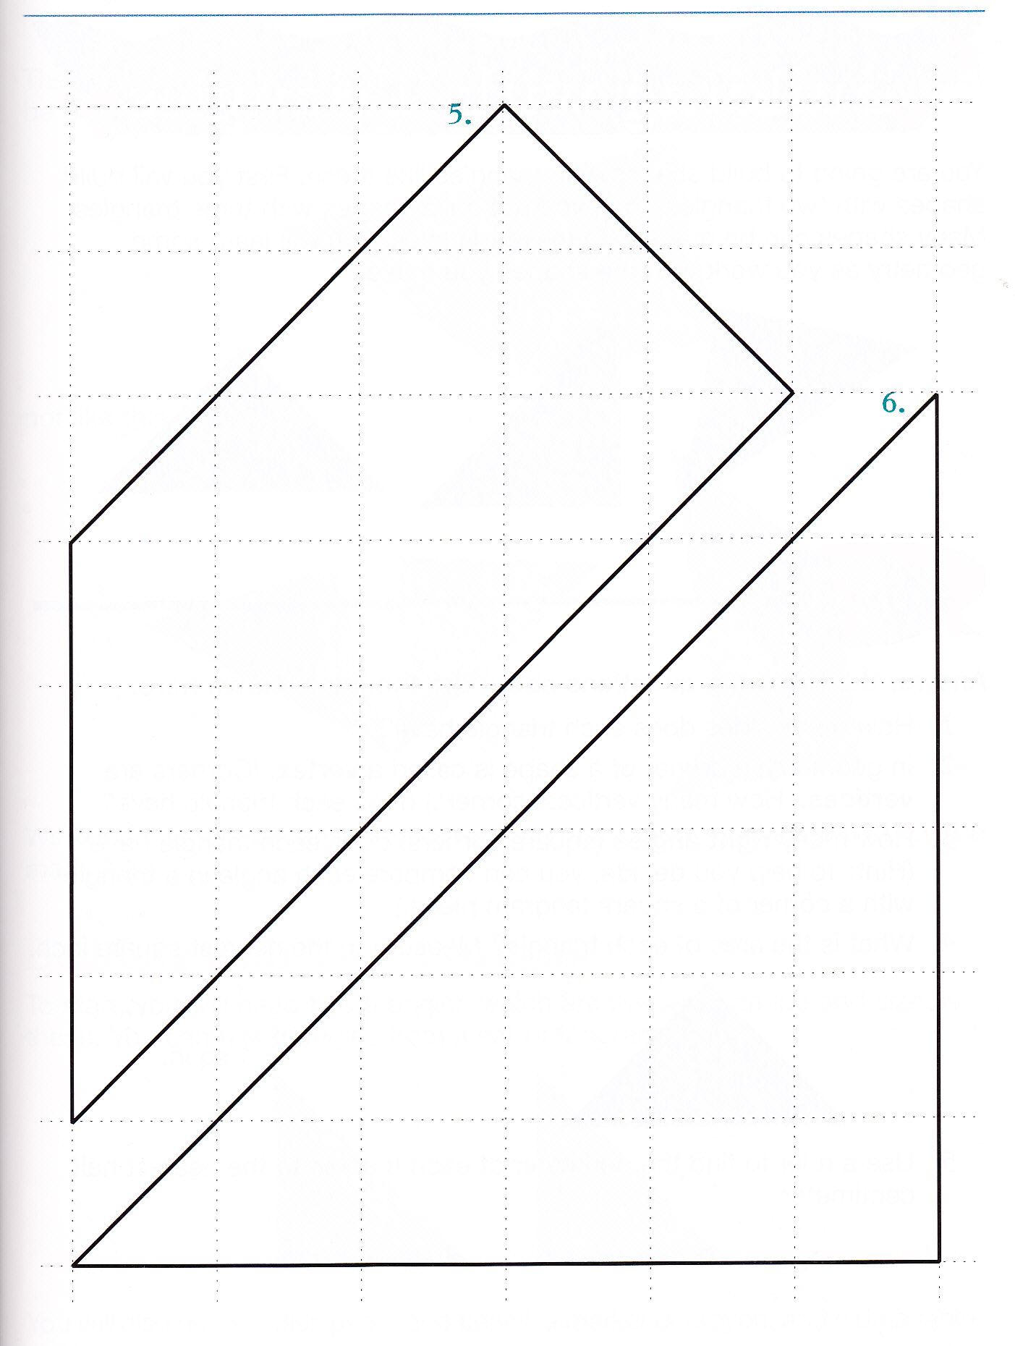

Grade 3, Math Trailblazers

