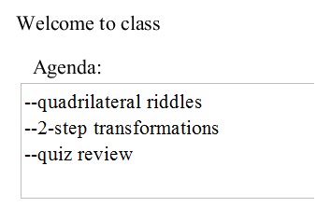
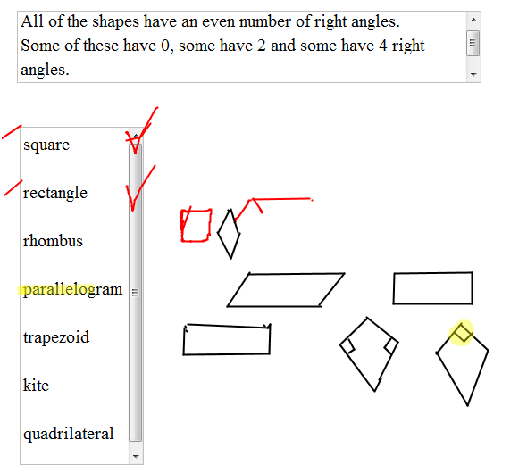
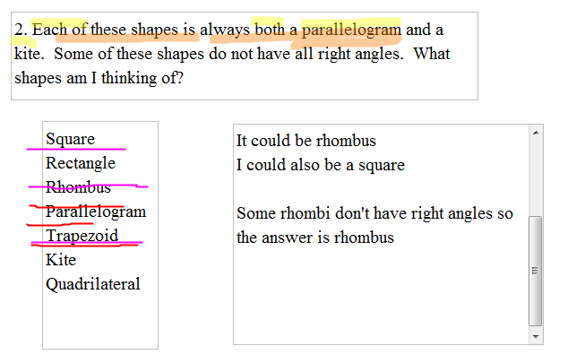
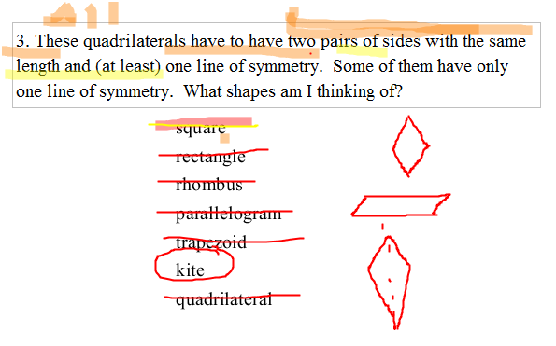
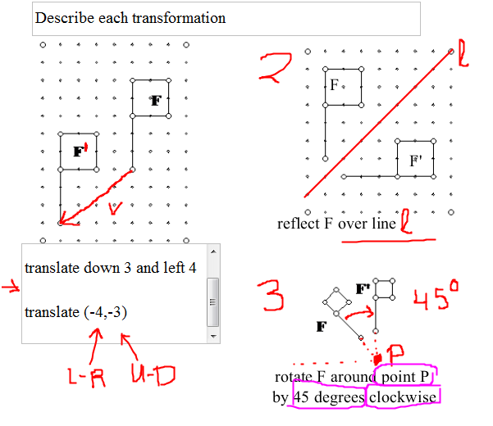
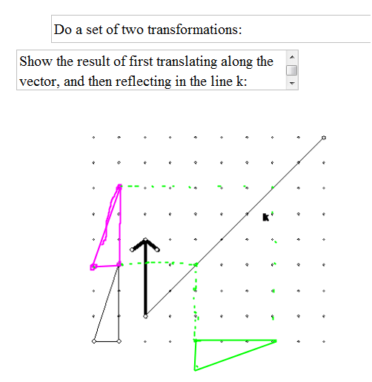
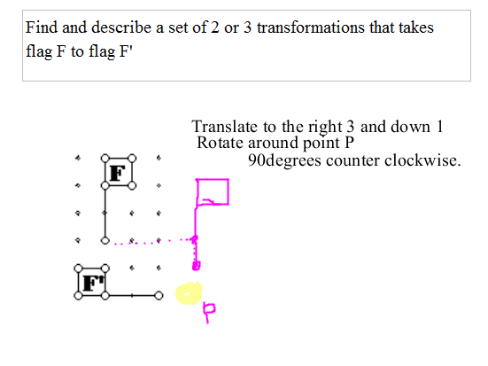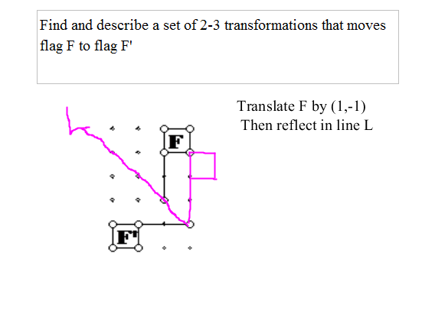

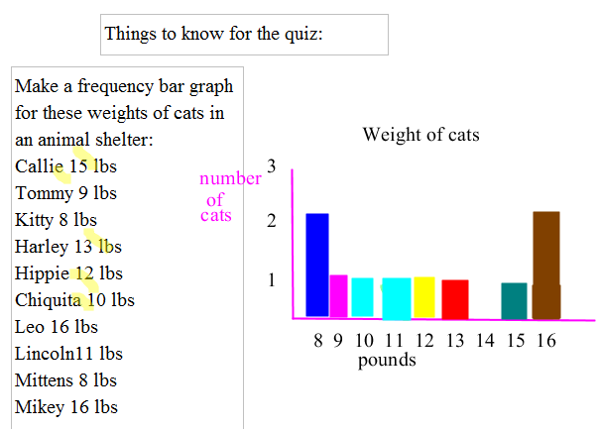
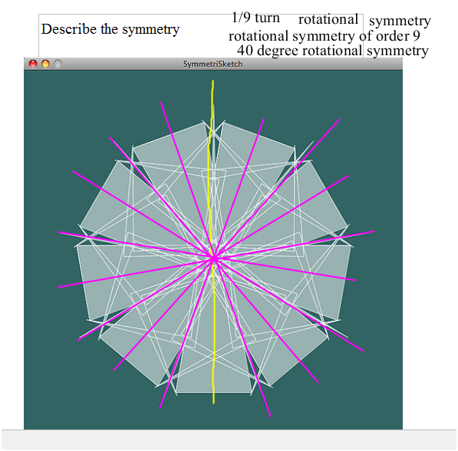
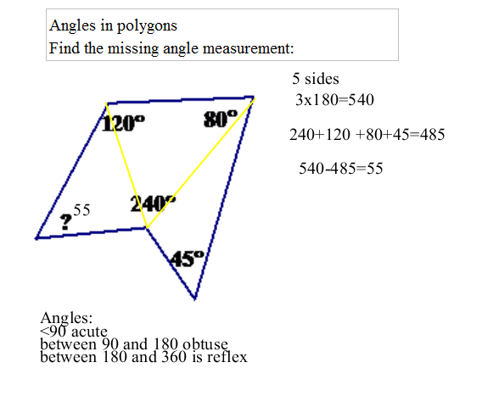
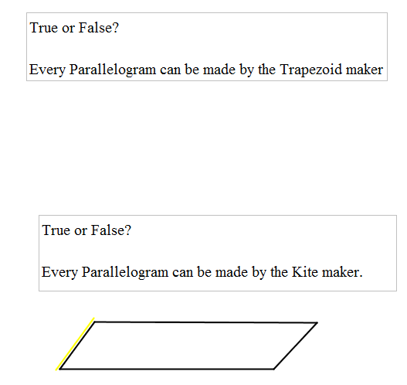

What properties do quadrilaterals have?
How many pairs of parallel sides?

Square has at least ______

Rectangle has at least ______

Rhombus has at least ______

Parallelogram has at least ______

Trapezoid has at least ______

Kite has at least ______

Quadrilateral has at least ______

What properties do quadrilaterals have?
How many congruent sides?

Square has at least ______

Rectangle has at least ______

Rhombus has at least ______

Parallelogram has at least ______

Trapezoid has at least ______

Kite has at least ______

Quadrilateral has at least ______

What properties do quadrilaterals have?
How many lines of symmetry?

Square has at least ______

Rectangle has at least ______

Rhombus has at least ______

Parallelogram has at least ______

Trapezoid has at least ______

Kite has at least ______

Quadrilateral has at least ______

