Answers to the practice questions:

1. Identifying and naming prisms and pyramids:
A B. C. D.
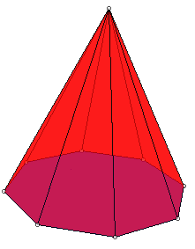
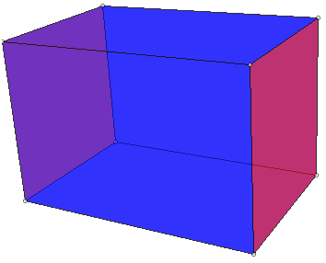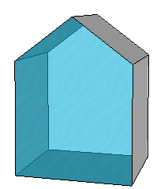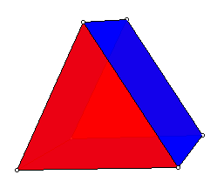
A. rectangular prism B.pentagonal prism C. Octagonal pyramid D. triangular prism*
D. is the one that is hardest for a lot of people, because they confuse it with a pyramid. If this were a pyramid, all of the faces but one would have to be triangles, and all of the triangles would have to meet at a single vertex.
E.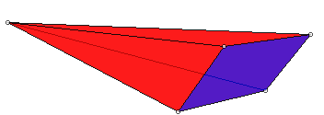 E. rectangular pyramid
2. Count the number of faces edges and vertices on a 3D shape like the ones above
 | A | B | C | D | E
V | 8 | 10 | 9 | 6 | 5
E | 12 | 15 | 16 | 9 | 8
F | 6 | 7 | 9 | 5 | 5

3. Sketch a net for a 3D shape like the ones above (Other ways of unfolding are possible and also correct. Don’t leave any “gluing-flaps” though, like you would have if you unfolded a box by pulling it apart rather than cutting it apart.
A B C
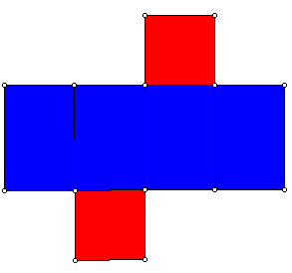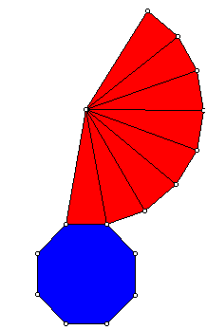
D. E.
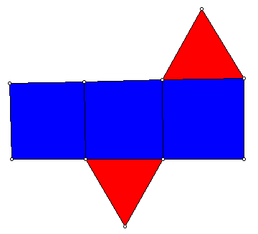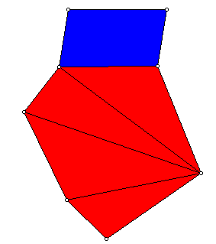
(yes, I know it’s impossible to tell the exact shapes of the triangles from the picture on E)

4. Write a fraction addition problem that could be solved with 2 sets of the fraction circles you have, where both denominators are the same, the sum is greater than 1, and the answer can be simplified further after trading in for 1 whole.
The problem in #5 is such an example, since 3/8 + 7/8 = 10/8 = 1 2/8 (trade in for 1) = 1 1/4 (simplify 2/8 = 1/4)

5. Write an illustrated explanation of how to find the sum (3/8) + (7/8) using fraction circles (show and tell each of the steps)
Show the two fractions using fraction circles:
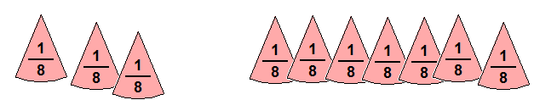
Put together the fraction pieces to make as many whole circles as possible:
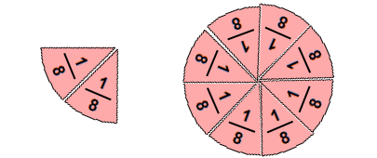
Try covering 2/8 with larger fraction pieces to find a fraction that 2/8 is equivalent to (eg. 1/2 is too big, 1/3 is too big, 1/4 is just right), and then trade in the whole circle for 1, and the 2/8 of the fraction 1/4 which is the same size/exactly covers it:
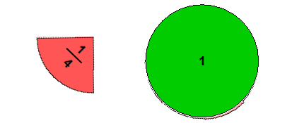
6. Tell a strength of each of these fraction materials:
- fraction circles: easy to see what 1 whole is; angles are good for visualizing; easy to see the missing part to make 1
- Cuisenaire rods: you can change easily what size 1 is by specifying a different rod as 1.
- paper squares: easy to make equivalent fractions by folding 1 way for a fraction, and folding in the opposite dimension to make an equivalent fraction.

7. If the whole shape is 1, what fraction is the shaded part?
1/6 (to see this, extend the vertical lines down from the top half)

8. What does the bottom number of a fraction tell about the amount?
It tells what size each piece is, and it tells me how many pieces of that size will make a whole.

9. What does the top (oops) number of a fraction tell about the amount? How many of the fraction sized pieces.

10. Explain how to show that using two different kinds of materials/manipulatives.
Fraction circles: cover 3/4 with 9/12 or vice versa:

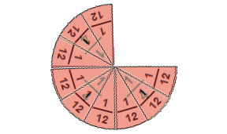
Fraction bars/tiles: 3/4 lined up with 9/12 lined up underneath
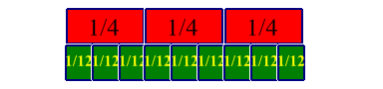
Paper squares: fold in 1/4-ths one way and shade 3/4. Then fold in 1/3-rds the other way to show 9/12.

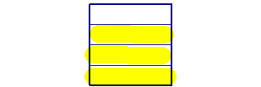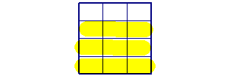

12. If this shape is 1 (compared to pattern blocks--I can’t control your printer’s sizing exactly, but I can tell you that you can assume that each short side here is supposed to be the same as the side length on a green triangle)

A. what fraction is a green triangle? 1/8
B. What fraction is a yellow hexagon? 3/4
C. Describe a shape that would show 5/4: 5 blue rhombi

13. If a red trapezoid is 1, what is a blue rhombus? 2/3

14. If a yellow hexagon is 2/3, what is 1? a yellow hexagon and a red trapezoid.

15. Write a word problem that tells the size of a whole discrete set, and asks how many are in a specified fractional part of the set.
eg. Sandy had 15 pencils. She gave 1/3 of them to Mike. How many pencils did she give to Mike?

16. Write a word problem that tells the size of a whole discrete set, and the size of a part of the set, and asks for the fractional name of the part as a fraction of the whole.
eg. Sandy had 15 pencils. She gave 3 of them to Mike. What fraction of her pencils did she give to Mike?

17. Write a word problem that tells the size of a partial discrete set, tells the fractional name of the part, and asks how many are in a whole set.
Mike has 2/3 of a box of crayons. He has 8 crayons. How many crayons are in a full box?

18. Write an addition of fractions word problem, where the fractional amounts are measured amounts of something.
eg. Jan has 1/4 of a yard of green ribbon, and 5/4 of a yard of red ribbon. How much ribbon does she have altogether?

19. Write a subtraction (aargh) of fractions word problem, where the fractional amounts are measured amounts of something.
eg. Kyle had 3/4 of a cup of juice. He drank 1/4 of a cup of the juice. How much juice does he have left?

20. For the following data
A. make a bar graph that would help answer how many people like the different pizza toppings
B. make a bar graph that would help answer how many people like plain, 1-, 2-, 3- or 4-topping pizzas
name | favorite pizza | name | favorite pizza
Allison | canadian bacon, mushroom, pineapple | Lindsay | pepperoni, canadian bacon, sausage, pineapple
Sam | pepperoni, mushroom, green peppers, tomatoes | Kelly | pepperoni, canadian bacon, sausage
Ted | pepperoni | Sandy | pepperoni, pineapple
Erin | cheese | Kylie | cheese
Jeff | sausage, mushroom, black olives, onion | Mitch | canadian bacon
Brenda | pepperoni | Bill | pepperoni
Kent | pepperoni, sausage, green peppers, onion | Jenny | pepperoni, green peppers, onion
Maria | pepperoni, pineapple | Lyle | pepperoni, sausage, mushroom, black olives

A.
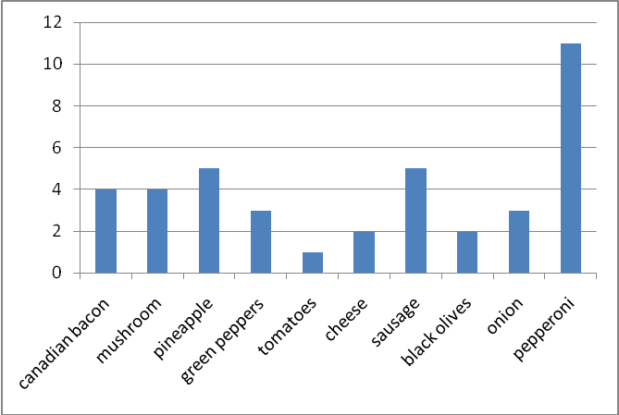
B.
