Things that might be on the quiz:

1. Identifying and naming prisms and pyramids:
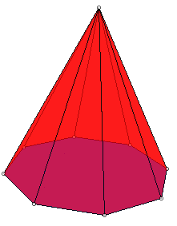
A B. C. D.
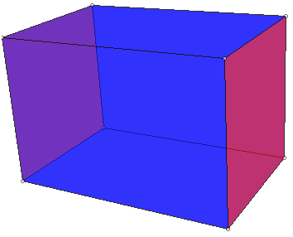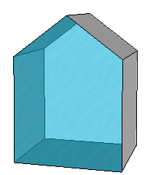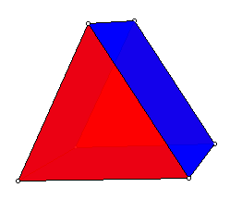
E.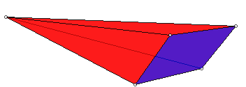
2. Count the number of faces edges and vertices on a 3D shape like the ones above

3. Sketch a net for a 3D shape like the ones above

4. Write a fraction addition problem that could be solved with 2 sets of the fraction circles you have, where both denominators are the same, the sum is greater than 1, and the answer can be simplified further after trading in for 1 whole.

5. Write an illustrated explanation of how to find the sum (3/8) + (7/8) using fraction circles (show and tell each of the steps)

6. Tell a strength of each of these fraction materials:
- fraction circles
- Cuisenaire rods
- paper squares

7. If the whole shape is 1, what fraction is the shaded part?

8. What does the bottom number of a fraction tell about the amount?
9. What does the bottom number of a fraction tell about the amount?

10. Explain how to show that using two different kinds of materials/manipuliatives.

12. If this shape is 1 (compared to pattern blocks--I can’t control your printer’s sizing exactly, but I can tell you that you can assume that each short side here is supposed to be the same as the side length on a green triangle)

A. what fraction is a green triangle?
B. What fraction is a yellow hexagon?
C. Describe a shape that would show 5/4

13. If a red trapezoid is 1, what is a blue rhombus?

14. If a yellow hexagon is 2/3, what is 1?

15. Write a word problem that tells the size of a whole discrete set, and asks how many are in a specified fractional part of the set.

16. Write a word problem that tells the size of a whole discrete set, and the size of a part of the set, and asks for the fractional name of the part as a fraction of the whole.

17. Write a word problem that tells the size of a partial discrete set, tells the fractional name of the part, and asks how many are in a whole set.

18. Write an addition of fractions word problem, where the fractional amounts are measured amounts of something.

19. Write an addition of fractions word problem, where the fractional amounts are measured amounts of something.

20. For the following data
A. make a bar graph that would help answer how many people like the different pizza toppings
B. make a bar graph that would help answer how many people like plain, 1-, 2-, 3- or 4-topping pizzas
name | favorite pizza | name | favorite pizza
Allison | canadian bacon, mushroom, pineapple | Lindsay | pepperoni, canadian bacon, sausage, pineapple
Sam | pepperoni, mushroom, green peppers, tomatoes | Kelly | pepperoni, canadian bacon, sausage
Ted | pepperoni | Sandy | pepperoni, pineapple
Erin | cheese | Kylie | cheese
Jeff | sausage, mushroom, black olives, onion | Mitch | canadian bacon
Brenda | pepperoni | Bill | pepperoni
Kent | pepperoni, sausage, green peppers, onion | Jenny | pepperoni, green peppers, onion
Maria | pepperoni, pineapple | Lyle | pepperoni, sausage, mushroom, black olives

