Graphing and data practice problems:

On the next page you will find 7 data sets. Different kinds of graphs are appropriate for different kinds of data sets.
Line graph-- good for seeing trends over time
Scatter plot-- good for seeing relationships between paired data
Circle Graph--good for seeing parts of a whole
Bar graph-- Use with category data. Good for showing frequencies.
Histogram--good for displaying number data that is grouped into intervals.
Box plot--good for seeing central tendency (what is typical of data), and especially for comparing two data sets
Line (dot) plot—good for showing central tendency of a single data set.

Task 1: for each of the data sets, list the kinds of graphs that it would be reasonable to make from the data.

Task 2: I chose each of these data sets to be particularly good for one of the types of graph above, see if you can find the best way to match up types of graphs and data sets, and make a graph for each data set.

Task 3: Try to figure out the original data based on the quiz scores bar graph given below. Use what you know about the original data to find the
a. mean,
b. mean absolute deviation,
c. median,
d. mode,
e. upper and lower quartile for the data.
f. Make a stem and leaf plot for the data

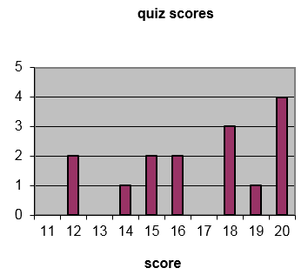
Data list: 12, 12, 14, 15, 15, 16, 16, 18, 18, 18, 19, 20, 20, 20, 20
a. 16.87
b. 2.41
c. 18
d. 20
e. 15, 19.5 or 20
f.
1 | 22455668889
2 | 0000
legend: 1|5=15

A. B. C. D.
avg spending on alcohol products  in a particular county | avg spending on tobacco products in a particular county |  | age | height |  | type of animal at shelter |  | name | birth month
avg spending on alcohol products  in a particular county | avg spending on tobacco products in a particular county |  | 0 | 26” |  | cat |  | Jen | Feb
avg spending on alcohol products  in a particular county | avg spending on tobacco products in a particular county |  | 1 | 31” |  | dog |  | Dave | Sept
avg spending on alcohol products  in a particular county | avg spending on tobacco products in a particular county |  | 2 | 35” |  | dog |  | Sarah | Oct
avg spending on alcohol products  in a particular county | avg spending on tobacco products in a particular county |  | 3 | 39” |  | cat |  | Paul | Feb
avg spending on alcohol products  in a particular county | avg spending on tobacco products in a particular county |  | 4 | 41” |  | cat |  | Nick | Mar
6.47 | 4.03 |  | 5 | 43” |  | cat |  | Anna | July
6.13 | 3.76 |  | 6 | 46” |  | other |  | Alice | July
6.19 | 3.77 |  | 7 | 48” |  | cat |  | Fred | May
4.89 | 3.34 |  | 8 | 51” |  | cat |  | Mike | Aug
5.63 | 3.47 |  | 9 | 53” |  | dog |  | Joan | Jan
4.52 | 2.92 |  | 10 | 55” |  | dog |  | Lisa | July
5.89 | 3.20 |  | 11 | 58” |  | cat |  | Carl | May
4.79 | 2.71 |  | 12 | 61” |  | other |  | Ted | Aug
5.27 | 3.53 |  | 13 | 66” |  | cat |  | Arnold | June
6.08 | 4.51 |  | 14 | 68” |  | cat |  | Liz | Nov
4.02 | 4.56 |  | 15 | 71” |  | dog |  | Jack | June
E. F. G.
#candies in 1 oz bag brand A | #candies in 1 oz bag brand B |  | name | height in cm. |  | Number of buttons on our clothes
18 | 20 |  | Jen | 164 |  | 6
19 | 24 |  | Dave | 181.5 |  | 1
24 | 26 |  | Sarah | 169 |  | 1
20 | 21 |  | Paul | 178 |  | 3
17 | 20 |  | Nick | 179 |  | 5
21 | 16 |  | Anna | 165.5 |  | 3
20 | 18 |  | Alice | 160 |  | 5
19 | 16 |  | Fred | 183 |  | 1
22 | 22 |  | Mike | 187 |  | 0
20 | 23 |  | Joan | 158 |  | 0
22 | 22 |  | Lisa | 165 |  | 1
21 | 25 |  | Carl | 181 |  | 2
18 | 19 |  | Ted | 172 |  | 5
20 | 17 |  | Arnold | 180 |  | 3
22 | 20 |  | Liz | 166 |  | 6
21 | 25 |  | Jack | 176 |  | 0

A: good choices are scatter plot and box plot. Here is a scatter plot:
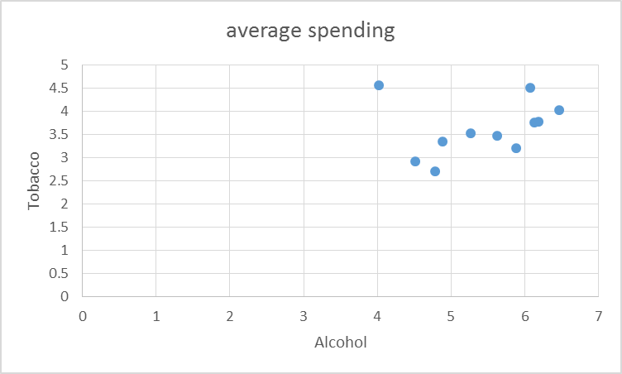
B. best choice is line graph
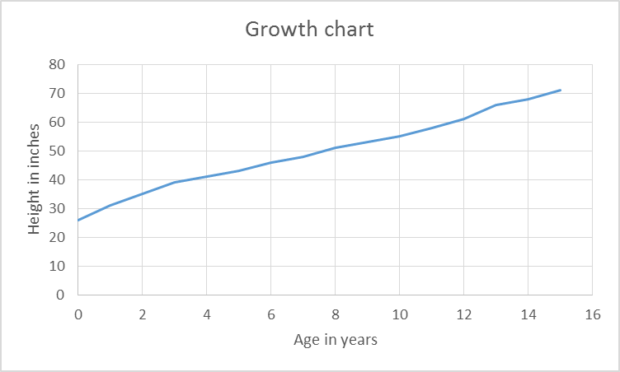
C: Circle graph and bar graph both work. Here is a circle graph:

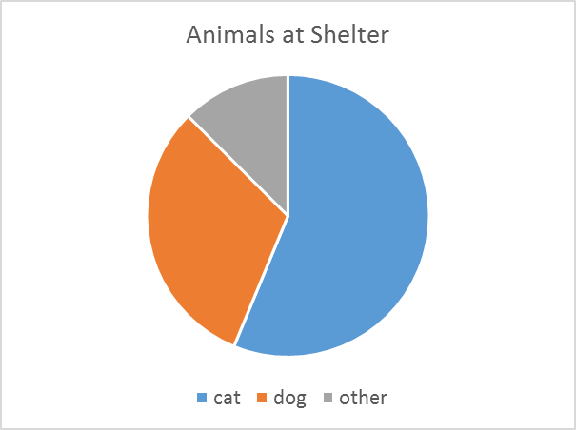
D. A circle graph or a bar graph would be appropriate. Here’s a bar graph (it’s OK to omit the missing categories, though it makes sense to keep them too in this case):
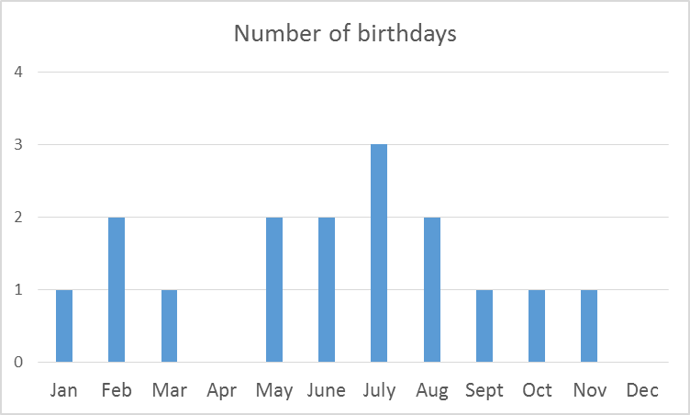’

E. Boxplot or side by side histograms would work here. Here’s a boxplot:

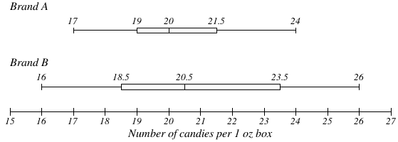

F. I think a histogram is best for this, though a box plot would be OK too.
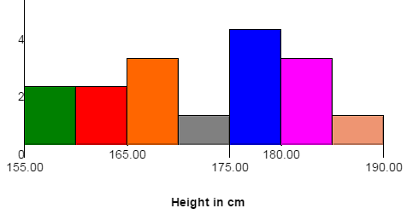
G. It would be easy to make a line plot/dot plot for this.

Number of buttons
X  X  X | X  X  X  X | X | X  X  X |  | X  X  X | X  X
| | | | | | | | | | | | |
0 | 1 | 2 | 3 | 4 | 5 | 6

