Identifying Prisms and Pyramids:

1. Give a definition of a prism. Make sure that an anti-prism does not satisfy your definition.

2. Here are some pictures of 3-D objects.
- For each shape, tell whether it is a prism, a pyramid or neither
- If it is a prism or a pyramid, shade in a face that would be the base of the prism or pyramid.
d
a
b
c

e
f
g
h

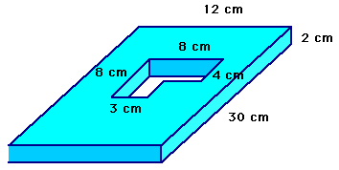
i
j
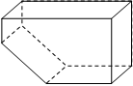
l
k
m
n

