Percents and discounts name:

1. Showing and converting some simple fractions to decimals using a 100-grid
A. Shade 1/4 of this grid.  How many squares does that cover?  What percent does it show?  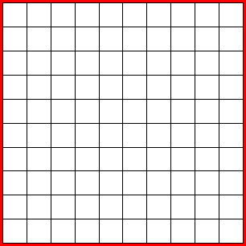 | B. Shade 1/5 of this next grid. How many squares does that cover?  What percent does it show?
C. Shade 1/2 of this grid.  How many squares does that cover?  What percent does it show? | D. Shade 1/10 of this grid.  How many squares does that cover?  What percent does it show?

E. Give 2 more examples of fractions that it would be easy to show on a 100-grid

Give 2 examples of fractions it would be hard to show on a 100-grid.

2. Shade the 100-grid below to show 72%:

If the whole square represents $300, what is a small square worth? (Show how you found it)

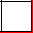 =
Use the value of the small square to find what the shaded area is worth. Show how you did it:

2. Shade the 100-grid below to show 20% with one color, and shade the rest of the grid with another color. The whole grid represents a price of $35.00.

What is a small square worth?

=

a. Use the value of a small square to find the value of the squares shaded with the 20% color

b. Use the value of a small square to find the value of the squares shaded with the 80% color.

c. Which value (a or b) would you use to find the discount on a $35.00 item that has been reduced by 20%

d. Which value (a or b) would you use to find the sale price of a $35.00 item that has been is reduced by 20%
3. This 100-grid is shaded to show an item that is on sale 30% off the original price. Circle the correct phrase to complete each statement

i. The whole grid shows a. the original price b. the sale price c. the discount (amount saved)

ii The left side of the grid shows  a. the original price  b. the sale price  c. the discount (amount saved) | 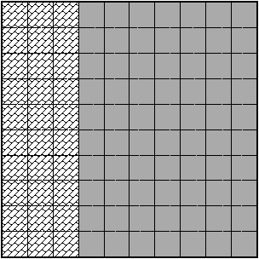 | iii. The right side of the grid shows  a. the original price  b. the sale price  c. the discount (amount saved)

4. Use the grid from #3 to help you answer the problem:

If the reduced (sale) price of an item that is on sale for 30% off its original price is $21.00, what was the original price?

a. What is what is a small square worth?

=

b. What is the original price?

c. What is the sale price?

d. What is the discount?

