Math 247 – An Investigation Lab on Loteria Name: _________________________

From D2L->Content, download the Microworlds Loteria game (you need to be on a computer that has Microworlds installed). In either the 1-player or the 2-player game, choose “New Loteria Card” repeatedly, covering all of the matching images on each of the boards when a card is selected (including duplicates on a single board) until all 6 of the game boards have won (been completely covered).

Example recording as the game is played: flower, fish, horse, bird, trees, trees, horse, heart, (board number 6 wins), harp, dog, fish, trees, cactus, (now also board 2 wins), …, until all 6 of your loteria cards win.

Predict Are any of the boards more likely to win than any of the others? Which ones? Why do you think so?

Listing for a Complete Game 1 (showing at what point which cards win – until all 6 boards win):

Here are your 6 two by two loteria boards to investigate:
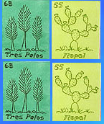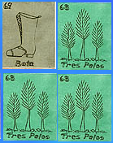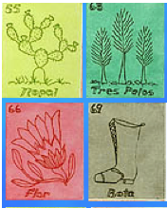
Loteria Board #1 Loteria Board #2 Loteria Board #3

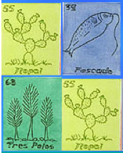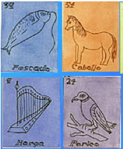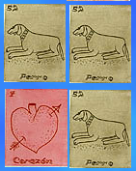
Loteria Board #4 Loteria Board #5 Loteria Board #6
For this first game/investigation:

How many cards did you go through before loteria board number 1 won? _______

How many cards did you go through before loteria board number 2 won? _______

How many cards did you go through before loteria board number 3 won? _______

How many cards did you go through before loteria board number 4 won? _______

How many cards did you go through before loteria board number 5 won? _______

How many cards did you go through before loteria board number 6 won? _______

Clear these boards and let’s do this again. Just to see if we see any patterns. Be sure to list each draw that takes place and mark at what point in the listing a particular loteria board (with its number) wins.

Listing:

For this second investigation, of the same boards:

How many cards did you go through before loteria board number 1 won? _______

How many cards did you go through before loteria board number 2 won? _______

How many cards did you go through before loteria board number 3 won? _______

How many cards did you go through before loteria board number 4 won? _______

How many cards did you go through before loteria board number 5 won? _______

How many cards did you go through before loteria board number 6 won? _______

Compare your results with others in the class (if you are doing this not in-class, you should print 2-copies of this sheet, and play at least 4 times), and then answer:

Which loteria boards seem to win fastest? Did that match your predictions? What properties of the boards do you think made them likely to win fast?
Explain:

