Justifying equations problem set:
For each problem, find an explicit function rule for the pattern of values, and explain, using deductive reasoning, why your function rule makes sense.

1.This is a red-blue pattern block train
train with 1 car train with 2 cars
train with 3 cars
Find an equation for the function rule that tells the perimeter of the pattern block train with n cars, and explain the rule deductively using properties of the pattern block train. (note: the perimeter of the train with 1 car is 7 inches.)

2. Mary got a 150 pieces of candy on Halloween. If she eats four pieces each day, how many pieces will she have left after n days? (Find an equation to answer this question, and explain deductively why the equation makes sense using properties of the problem situation.)

3. A certain pool company makes decorative square pools that are white with a border of blue tiles, like this:
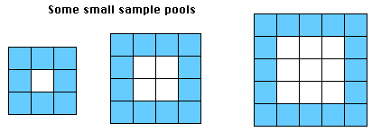
A. If the center of a certain pool is n white tiles wide, how many white tiles does it take to make the center of the pool? (Explain deductively why your rule makes sense.)

B. If the center of a certain pool is n white tiles wide, how many blue tiles does it take to make the border of the pool? (Explain deductively why your rule makes sense.)

4. Deductively explain the function rule for this WisWeb pattern:
