1. Use the Pan Balance-Shapes applet: http://illuminations.nctm.org/ActivityDetail.aspx?id=33
And record your solutions to sets 5 and 6:
Set 5 |  | Set 6
 | = |  | =
 | = |  | =
 | = |  | =
 | = |  | =

Use the given weight and the information from these pictures to find the other weights . Explain how you figured it out.
2.
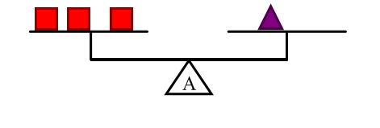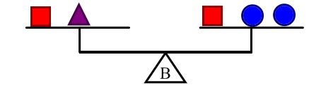
=
=
= 6 oz

3.
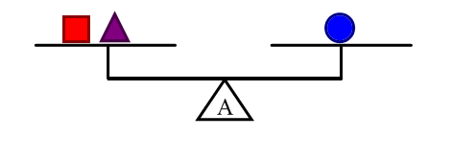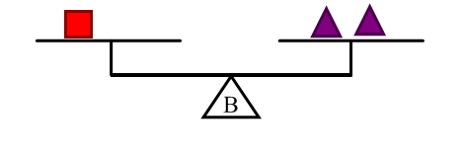
=
= 12 oz
=

4. I made these problems a bit more difficult than the ones on the applet. What are some ways in which I made them more difficult?

5. Solve the 3-Pan Balance problems from the article Algebraic Problem Solving in the Primary Grades. Show how you solved them:

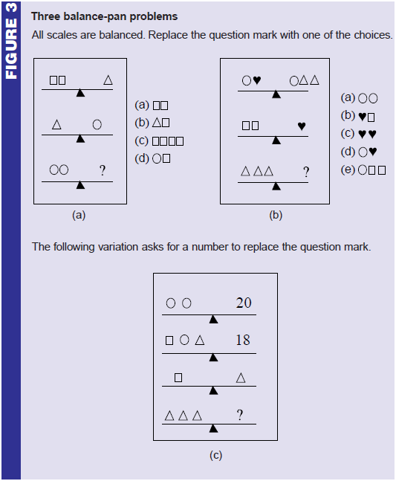
6. Scales A and B show two ways to balance the weights. (This is a hard one, but I have confidence that you can figure it out!)
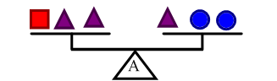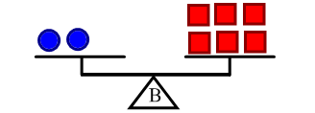

Tell as many ways as you can find to balance scale C
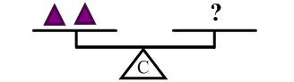
You have now seen 3 or 4 different kinds of weight balance problems: The ones in the article Algebraic Problem Solving in the Primary Grades, the Balancing Act problems, the applet Pan Balance-Shapes problems and my extensions, and the Block Pounds questions.

6. Which of the problems did you think were most interesting? What did you like about them?

7. Write two more problems of the type you preferred, one problem being more difficult than the other.

8. Of the two problems you wrote, which was more difficult? What makes it more difficult than the other one?

9. Solve these missing number problems. A □ always stands for the same amount within the same equation, so if there are several □’s in a single equation, all of the □’s stand for the same number.

a. 4 + □ = 15 – 3

b. 3 + 6 = 11 - □

c. □ + □ + 3 = 11

d. 10 = 20 - □ - □

10. Write two more playing card/missing number problems that are elementary-aged appropriate.

