Subitizing and AL Abacus Assignment.

1. What is the difference between perceptual and conceptual subitizing?

2. What is the difference between subitizing and counting?

3. One activity for building visualizing skills is to quickly flash a representation, and have children say the number. The representation might be dots in a pattern, dots on a ten frame, AL Abacus-type dots, tally marks or fingers held up. Using some or all of these, show 6 different ways to show 7. Your diagrams should have a reasonable amount of variety, while still satisfying the recommendations in the article Subitizing: What Is It? Why Teach It? for initial pictures of groups to be subitized (see page 403).

4. Circle the dots (or use a screen capture from the Smart Notebook abacus) to show how you would represent the number 69 on this abacus
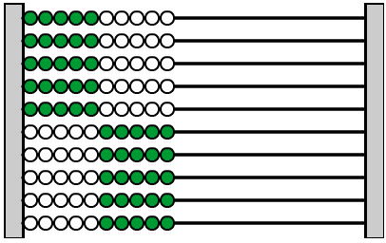

5. Draw 3 different ways of representing the number 48 using place manipulatives (not number cards—I don’t want just a written number). Arrange the materials in your sketch in a way that the amount 48 could be readily recognized without counting.

6. Describe an example from the article Using Language and Visualization to Teach Place Value of how visualization helps children learn addition.

