The commutative and distributive laws/properties are the two most useful multiplication properties for helping you figure out multiplication facts.
1. a. Write an equation that shows what the commutative law says about 3×6

1. b. Draw a diagram that shows why the commutative law is true for 3×6 (your picture should illustrate the equation you wrote for 1a), and you should label it and write an explanation of how you can be sure without calculating the numbers for both sides that that the equation you wrote in part a is true.

2. a. Write an equation that shows how to use the distributive law, including one of the 5× facts to figure out 7×6

2. b. Draw a labeled picture and write an explanation that shows how you can be sure without calculating the numbers for both sides that the distributive law equation you wrote for 2a. is true.

3. Once upon a time, I was working with 3 children on a multiplication problem, and this problem had a lot of 5’s in it. We were using manipulatives that look like this:

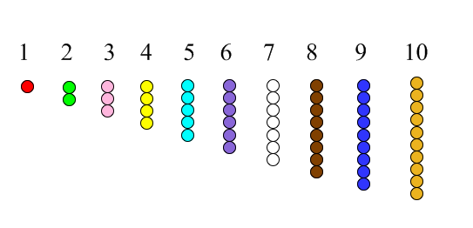
So, to show $4×5$, usually you would represent it this way:
But we had run out of 5’s, so I asked the children what to do. These are the 3 ways they suggested we could use the manipulatives to show $4×5$:
A. B. C.
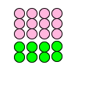
Write me your best analysis of each of these 3 ways of showing $4×5$.
a. What was child A thinking when he did what he did? (Does his thinking relate to either the commutative or distributive law, or is it a strategy that uses addition or counting or…?)

b. What was child B thinking when she did what she did? (Does her thinking relate to either the commutative or distributive law, or is it a strategy that uses addition or counting or…?)

c. What was child C thinking when she did what she did? (Does her thinking relate to either the commutative or distributive law, or is it a strategy that uses addition or counting or…?)

