Use the lettered shapes on the next page to answer these questions.

1. Put the triangles where they belong in this table. Use the inclusive definition of isosceles
Triangles | Acute | Right | Obtuse
Isosceles (at least one pair of congruent sides)
Scalene

2. Put the quadrilaterals (H-R and U) where they belong in this table
Quadrilaterals | At least one pair of equal opposite angles | No opposite angles are equal
At least one pair of equal sides
No equal sides

3. Draw the Venn diagram relating rhombi and trapezoids. Use the exclusive definition of trapezoid (one and only one pair of parallel sides). Put an example of a shape in each part of the diagram that should have a shape.

4. Draw the Venn diagram relating rectangles and kites (use the inclusive definition of kite—two pairs of equal adjacent sides). Put an example of a shape in each part of the diagram that should have a shape.

5. Figure out a property that could be a rule for each of these ways of sorting polygons (Hint: these are both rules about angles)
a.
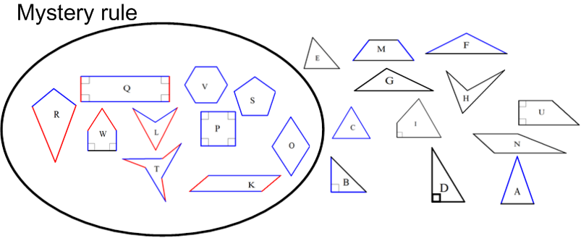
b.
