Patterns homework: name:

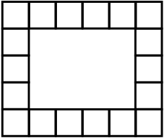
1. I wish to make a pattern on this border mat.

a. Which of these patterns below will form a completed pattern for this border?

i) AB ii) AAB iii) AABB iv) ABCBA

b. Tell another length of pattern that would fit perfectly on this border.

2. Explain the rule for how the length of the pattern and the number of squares in the border help you figure out whether the unit pattern will make a complete border pattern. Why does the rule make sense?

3. Design a border mat for which an AAABB pattern would be complete but an AABB pattern would not be complete

Draw or describe your border mat.

4. This is a growing pattern made out of pattern blocks. My pattern is for a fir tree growing
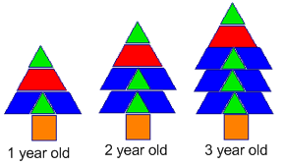

a. Write a good “getting started” question about the fir tree pattern

b. Write a good follow up problem for first graders

c. Write several follow up problems for third graders (starting easier and getting harder)

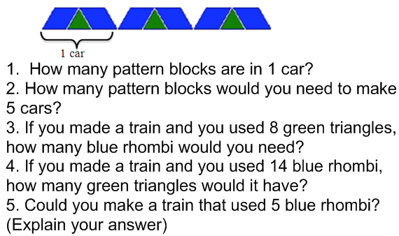
5. Make a pattern, and write questions for a problem similar to the train car problem we discussed in class.

6. Choose one of these problems to solve. Show your problem solving process using the prompts below.

a. Suppose yesterday was Tuesday. What day of the week will it be 100 days from now? | b. The square on the right is divided into three congruent rectangles (as shown). Each of the three rectangles has a perimeter of 16 meters. How many meters are in the perimeter of the square?

Which problem are you trying to solve?___

Understand the problem:
What are you trying to find?

What information are you given?

What relationships or other information do you know that might be helpful?

Make a plan:
What are some ways one could try to solve this problem?

Show your work in solving the problem:

Check your answer: find a way of checking your answer that’s not just doing the same strategy again.

