Patterns homework: name:
1. Tile Border Walkway. Recycled red, r, and gray, g, tiles will be used to form a pattern on this border for the elementary school butterfly garden.

Which of these patterns below will form a completed pattern for this border?

i) rrg ii) rrgg iii) rrrgr iv) rrggrg

Explain how you determined this:

Extra Border Grids

2. Design a border mat for which an AAABBB pattern would be complete but an AAABB pattern would not be complete

Draw or describe your border mat.
3. Which of these basic repeating units make patterns that are exactly the same as each other:

i) rgg ii) rggr iii) gggrg iv) rggrgg

Explain how you determined this:

4. Write the letter (eg. AB) representation of the basic pattern for each of these four patterns (a-d). Then tell which patterns have the same alphabetic representation (i.e. which two patterns have the same form, even though they aren't identical?)

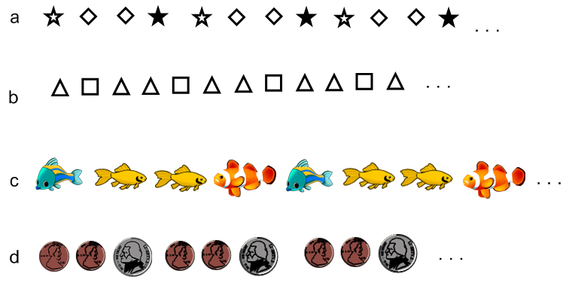

Don't forget to answer which two of these patterns are have the same alphabetic representation?
5. This pattern continues:
1 2 3 4 5 6 7 8 9 10…
▼ ▼ ▼ ▲ ▼ ▼ ▼ ▲ …

a. Which way will the triangle point that goes under the number 10?

b. Which way will the triangle point that goes under the number 16?

c. Which way will the triangle point that goes under the number 100?

d. What pattern can help you with a, b, c?

e. Which way will the triangle point that goes under the number 101?

f. Which way will the triangle point that goes under the number 79?

g. Which way will the triangle point that goes under the number 65?

h. How did you figure out e, f, g?

6. This is a growing pattern made out of pattern blocks. It shows a prickly caterpillar
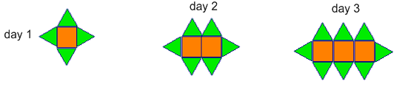
a. Sketch what a 4 day caterpillar will look like.

b. If the caterpillar has 50 squares, how many triangles will it have?

c. How do you know?

d. If the caterpillar has 14 triangles, how many squares will it have??

e. How do you know?

f. Will the caterpillar ever have 11 triangles?

g. How do you know?

6. This is a growing pattern made of squares:

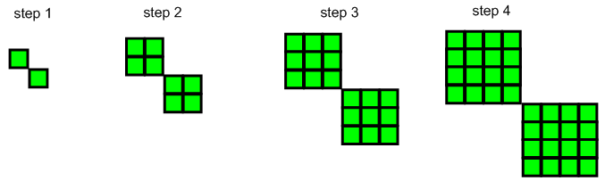
a. Draw or describe the step 5 pattern:

b. How many small squares would be in the step 20 pattern? (Show how you figured it out)

