Patterns homework:

1. Write the letter (eg. AB) representation of the basic pattern for each of these four patterns (a-d). Then tell which patterns have the same alphabetic representation (i.e. which two patterns have the same form, even though they aren't identical?)

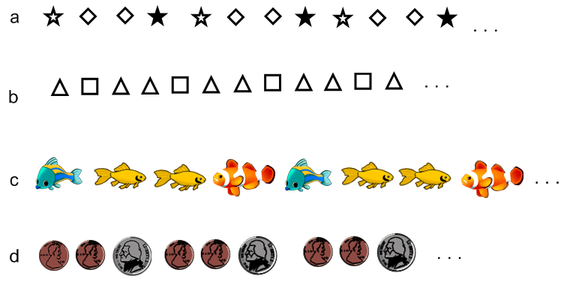

e. Don't forget to answer which two of these patterns are have the same alphabetic representation...

2. If you were showing an ABB pattern with pattern blocks, how much of the pattern should you show so that children would be able to figure out and understand what the pattern is?
3. This pattern is:
1 2 3 4 5 6 7 8 9 10…
▼ ▼ ▼ ▲ ▼ ▼ ▼ ▲ …

a. Which way will the triangle point that goes under the number 10?

b. Which way will the triangle point that goes under the number 16?

c. Which way will the triangle point that goes under the number 100?

d. Which way will the triangle point that goes under the number 90?

e. Which way will the triangle point that goes under the number 101?

f. Which way will the triangle point that goes under the number 79?

g. Which way will the triangle point that goes under the number 65?

h. How did you figure out the answers above? If you wrote out the pattern all the way to 100, try to think of another way to figure out the answers to c-g.

4.
1 | 2 | 3 | 4 | 5 | 6 | 7 | 8 | 9 | 10 | 11 | 12 | 13 | 14
Where are the ? 3 6 ___ ___ ___ ___ ___ ___
Where are the ? 1 4 ___ ___ ___ ___ ___ ___
Where are the ? 2 5 ___ ___ ___ ___ ___ ___

The skip count pattern for is to start at 3 and skip count by 3. What is the skip count pattern for the squares?

5. Fill in these skip counting puzzles:

a. 10 , 15 , 20 , __ , __ , __

b. __ , __ , __ , 11 , 13 , 15

c. __ , 12 , 15 , __ , 21

d. 13 , 16 , 19 , __ , __

e. 17 , 22 , __ , __ , __ , 42

