Complex numbers, Julia Sets, and the Mandelbrot Set.

1. Show geometrically how to use the angle, radius and translation to compute  for

a.  and 

b.  and 

(note: I want to see angles and radii and translation vector—I don’t need/want to see any algebra or know eht exact answer.)

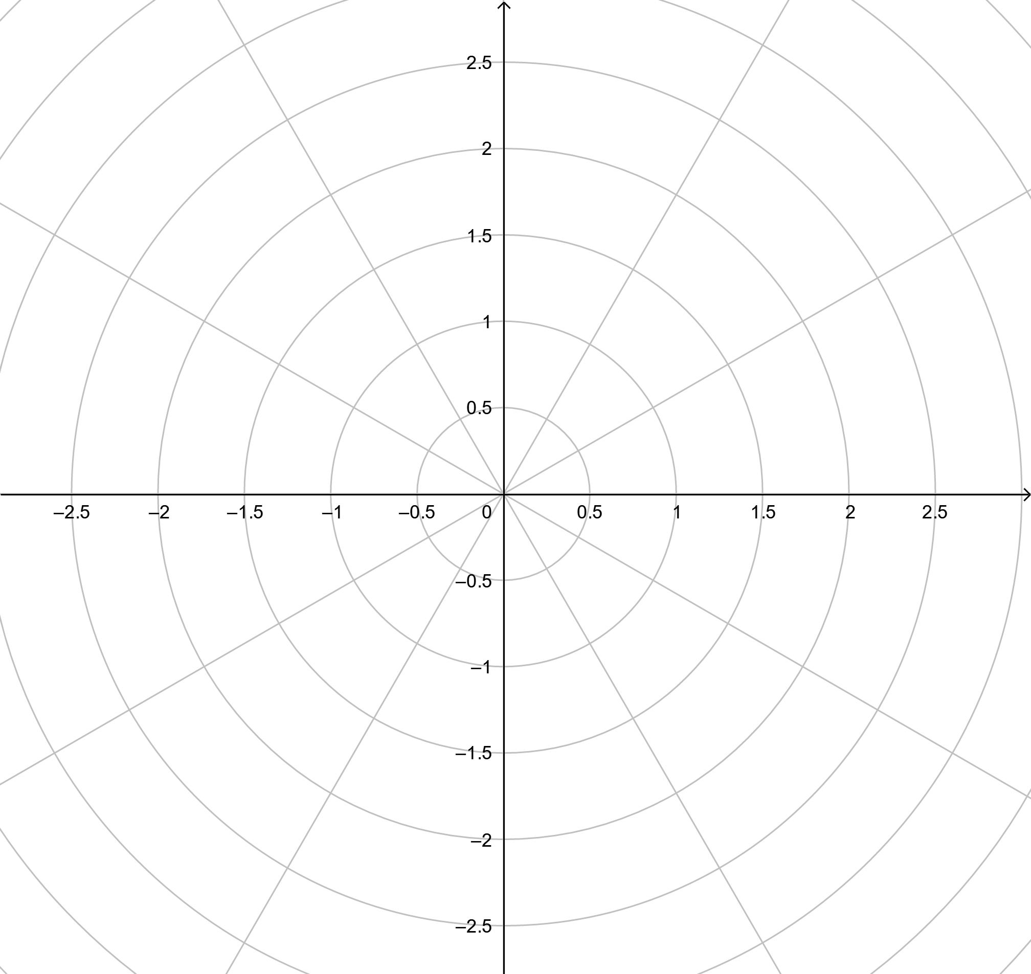 

2. In both Mandlebrot and Julia sets, you (or your computer) calculate  many times. For a specific value of *c* (something like ),

a. What is this iterated calculation figuring out if you are doing it for a Mandelbrot set? (What number or numbers are you choosing for ? What number or numbers are you choosing for *c*? How do  and *c* correspond to the points in the Mandelbrot set?)

b. What is this iterated calculation figuring out if you are doing it for a Julia set? (What number or numbers are you choosing for ? What number or numbers are you choosing for *c*? How do  and *c* correspond to the points in the Julia set?)

3. We say that the Mandelbrot set is a fractal with dimension somewhere between 1 and 2. What part of the Mandelbrot set is the fractal part? (is it the big blob of black in the middle, is it one of the colored stripes around the edge? This is related to the question of what part of a Koch snowflake is the fractal.)

4. Typically a Mandelbrot or Julia set is drawn with a black shape near the center and bands of colored regions around it.

a. What does the black shape near the center represent? (What is true of the points in that set of region)?

b. What do the colored regions represent? (What is true of the points in that region)?